Supporting the Moldovan authorities in the sustainable management of the Dniester River

Research Monitoring Programme for Identification of Water Framework Directive ‘Priority and certain other pollutants’ in the Moldovan Dniester River Basin District
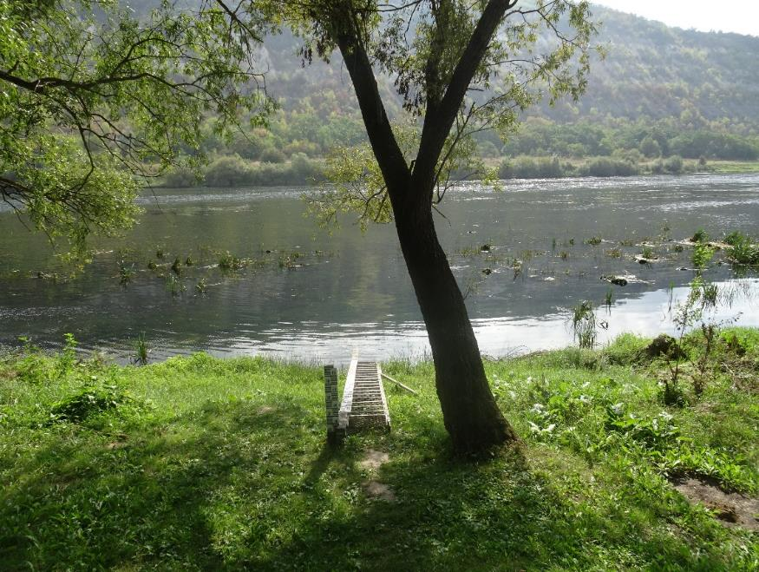

Executive summary

Table of Contents
1 Introduction 1
2 Approach 3
2.1 Sampling 3
2.2 Laboratory analysis 4
3 Results 5
4 Conclusions 8

Introduction
As a candidate EU Member State, the Republic of Moldova is getting itself prepared for complying with the ‘acquis communautaire’. The Moldova-European Union Association Agreement (signed on 27 June 2014) came fully into force on 1 July 2016.
The UNDP project “Supporting the Moldovan authorities in the sustainable management of the Dniester River” provides – inter alia – support towards reaching compliance with the Water Framework Directive, including legal harmonization, strengthened water quality monitoring, and improved data processing and reporting in line with EU integration obligations.
Chapter 27 of the Association Agreement deals with environment and climate change, among which the Water Framework Directive (WFD). The WFD concerns a comprehensive approach towards integrated management of the quality of surface waters and groundwaters, with ‘good status of all bodies of waters’ as ultimate objective.

For surface water this objective means that waterbodies must be of good ecological status and good chemical status.
- The ecological status is largely determined by biological quality elements, such as fish, water plants, organisms dwelling in and on the river bed, phytoplankton, and more.
- The chemical status is determined by concentrations of the so-called ‘Priority and certain other pollutants’, currently defined in the Directive 2013/39/EU .

The Project Document refers to chemical status under
- COMPONENT 4: Implementation of the on-the-ground activities to improve current ecological conditions of the Dniester River
  - Outcome 8: Chemical status of water bodies in the Dniester River Basin District
    - Output 8: Sampling program on Dniester, tributaries, and underground waters implemented, and data obtained and analysed.
The Project Document notices that little information is available about the presence of the ‘Priority and certain other pollutants’ in Moldovan surface waters. Therefore, it instigated to conduct sampling and laboratory analysis under a Research monitoring programme. The programme described in the Project Document comprises 105 sites, to be visited once per year during three years, with water, sediment and biota samples to be taken. The samples were to be analysed the Water Quality Laboratory of the Environmental Reference Laboratory of the Environment Agency.
However, during a scoping mission in September 2024 it turned out that the Water Quality Laboratory was not capable of analysing the full range of ‘Priority substances and certain other pollutants’ (hereinafter referred to as Priority substances).
Preliminary orientations among laboratories abroad indicated that costs for analysis of Priority substances in one water sample were around USD 2,000. Implying costs for analysis of 105 (sites) * 3 (years) water samples about USD 600 thousand (excluding various overhead); disproportionally high compared with the then project budget of USD 2.1 million.
Thus, the research monitoring programme had to be revised (more details are provided in the next chapter). In advance it should be emphasized that the main purpose of this research monitoring programme is to examine the presence/absence of Priority substances. Both the number of sites (9), as well as the number of samples taken per site (3) are in principle too small for assessment of the chemical status of the surface waterbodies inside the Moldovan Dniester River Basin District.
The programme was approved by the Project Board during their meeting in October 2024.
The related Request for Quotation was published in December 2024. A suitable offer was submitted by the Environmental Institute from Koš, Slovak Republic. The Environmental Institute took care of both sampling and laboratory analysis.

Approach

Sampling
Nine sites were selected, presumed to be representative for wider areas of the Dniester River Basin District. The sites are included in the regular national surface water quality monitoring, except for Nimereuca.
Figure 2-1 Overview of the sampling sites
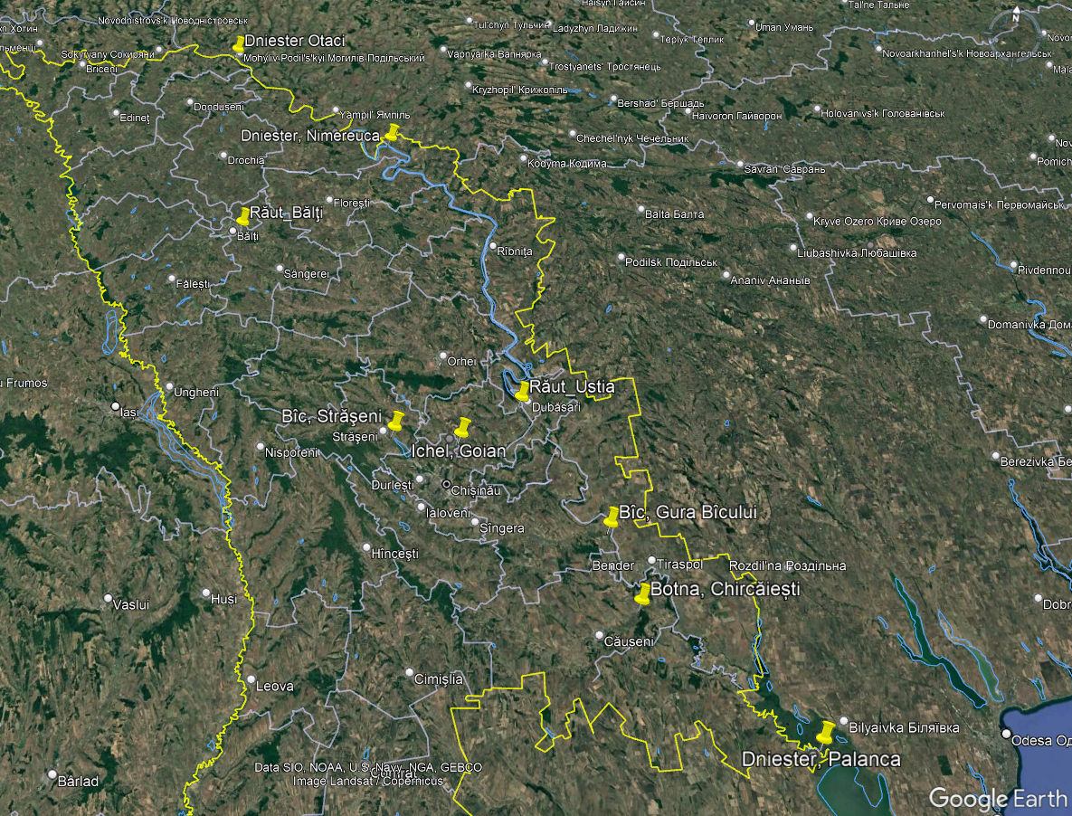
Table 2-1 Features of the selected sampling sites
River | Location | Features
Dniester | Otaci | Upstream border with Ukraine
 | Nimereuca | End of stretch with shared border, entry into Moldovan territory
 | Palanca | Downstream border with Ukraine
Răut | Bălţi | Downstream large city
 | Ustia | Downstream overall: combination of point sources and agriculture
Ichel | Goian | Downstream overall: combination of point sources and agriculture
Bîc | Străşeni | Downstream medium-sized city; agriculture  (and upstream Ghidighici Reservoir)
 | Gura Bîcului | Downstream large city
Botna | Chircăiești | Downstream overall: combination of point sources and agriculture

Water samples were taken during 18-20 April 2025, 14-16 July 2025 and 16-18 October 2025, following the schedule in Table 2-2. Water temperature, conductivity, dissolved oxygen, pH and hardness were measured on site.
Table 2-2 Sampling scheme per survey round
Day | Site
Day 1 | Otaci
Day 1 | Nimereuca
Day 1 | Bălți
Day 2 | Ustia
Day 2 | Goian
Day 2 | Străşeni
Day 2 | Gura Bîcului
Day 2 | Chircăiești
Day 3 | Palanca

Laboratory analysis
Annex 1 contains the list with Priority substances and the environmental quality standards included in the Directive 2013/39/EU. It concerns 45 main entries, some of them encompassing more than one substance.
The Environmental Institute reported a few more substances that can be considered as ‘family members’, like DDD and DDE which are part of total DDT. The laboratory furthermore analysed 38 PFAS compounds, which though are not included in the Directive 2013/39/EU. In total 107 substances were analysed.
Table 2-3 Overview of categories of analysed substances
Category | Substances | Remarks
Heavy metals | cadmium, lead, mercury, nickel
Organochlorine pesticides | aldrin, chlorvinfos, DDT, more
Other pesticides | atrazin, diuron, quinoxyfen, more
Polyaromatic hydrocarbons | anthracene, fluoranthene, more
Volatile organic compounds | 1,2-dichloroethane, benzene, more
Industrial pollutants | chloroalkanes, nonylphenols, more
Tributyltin compounds | tributyltin compounds
PFOS | perfluorinated compounds | PFOS are a subgroup of PFAS
PFAS | per- and polyfluoroalkyl substances | Not included in Directive 2013/39/EU

Results
AA-EQS, MAC-EQS
The Directive 2013/39/EU contains two sets of environmental quality standards for assessment of the chemical status
- AA-EQS: annual average environmental quality standard
  - This EQS is to be applied to the arithmetic average/mean of a number of samples taken throughout the year. WFD Annex V. 1.3.4 indicates monthly sampling, thus 12 samples per year.
- MAC-EQS: maximum allowable concentration environmental quality standard
  - This is a figure not to be exceeded any time, thus in none of the samples.

In case the concentrations of all detected Priority substances comply with the AA-EQS and the MAC-EQS, then a surface waterbody can be qualified as being of ‘Good’ chemical status.
Otherwise, the waterbody has to be qualified as ‘Failing to achieve good’ chemical status.

In total 62 (individual) Priority substances of the Directive 2013/39/EU were analysed, out of which:
- 34 substances were not detected, i.e. not found in concentrations above the limited of detection (LOD) of the laboratory analysis;
- concentrations of 16 substances were safely below the environmental quality standards (EQSs) defined in the Directive 2013/39/EU;
- concentrations of 12 substances were near to or higher than the EQSs defined in the Directive 2013/39/EU.
Annex 2 contains an overview of the Priority substances that were detected in one or more of the samples taken in April, July and October. This overview shows that the presence of the detected Priority substances is not ubiquitous. Not surprisingly, the highest numbers of detected Priority substances were found in the samples taken downstream Bălţi and at Gura Bîcului, downstream Chișinău.
The 50 substances that were not detected, either with concentrations safely below their EQSs, do not require immediate attention, especially since resources for monitoring and laboratory analysis are yet limited.
Three (3) Priority substances were found with concentrations exceeding the MAC-EQS, which by definition implies ‘Failing to achieve good’ chemical status.
- Mercury in the April samples taken from the Bic River at Gura Bîcului and from the Botna River at Chircăiești.
- Chlorpyrifos (chlorpyrifos-ethyl) in the July sample taken from the Raut River downstream Bălţi.
- Tributyltin compounds in the April and October samples taken from the Dniester River at Otaci and Nimereuca.
The other nine (9) substances concern concentrations that were near to or higher than the AA-EQS. There were sometimes considerable differences between the concentrations of the samples taken at one site. Three samples are too low a number for statistically robust checking compliance with the AA-EQS. Nevertheless, these nine substances indicate that there might be risks of not achieving good chemical status.
Table 3-1 Priority substances considered for short/medium term attention
 | DNIESTER |  |  |  | RĂUT |  |  | ICHEL |  | BÎC |  |  | BOTNA
Substance | Otaci | Nimereuca | Palanca |  | Bălţi | Ustia |  | Goian |  | Străşeni | Gura Bîcului |  | Chircăiești
Mercury |  |  |  |  |  |  |  |  |  |  | √ |  | √
Chlorpyrifos |  |  |  |  | √
Tributyltin compounds | √ | √ | √
Nickel |  |  |  |  |  |  |  | √ |  | √ | √ |  | √
Heptachlor epoxide A ^{(*)} |  |  |  |  | √ |  |  |  |  |  | √
PFOS |  |  |  |  | √ |  |  |  |  |  | √
Nonylphenols |  |  |  |  | √ |  |  |  |  |  | √
Chlorfenvinphos |  |  |  |  |  |  |  |  |  |  |  |  | √
Dieldrin |  |  |  |  |  |  |  |  |  |  | √
Diuron |  |  |  |  |  |  |  |  |  |  | √
Terbutryn |  |  |  |  |  |  |  |  |  |  | √
Fluoranthene |  |  |  |  | √
^{(*)} Concentrations were just above the limit of detection, hence results should be interpreted with caution.
√ | one or more concentrations >MAC-EQS
√ | one or more concentrations >AA-EQS
√ | one or more concentrations >0.66 * AA-EQS

The above table shows that the twelve Priority substances requiring short/medium term attention are constrained to specific (stretches of the) tributaries and in the case of tributyltin compounds to the Dniester River itself.
Sources for emissions of these substances are situated upstream the sampling sites, but cannot be pinpointed with the results of this Research monitoring programme. Identifying which are the sources, situated where, will require a combination of investigative monitoring (taking samples further upstream) and desk studies.
Table 3-2 Likely sources of the selected Priority substances
Priority substance | Likely sources
Chlorfenvinphos  Chlorpyrifos  Dieldrin  Diuron  Heptachlor epoxide A  Terbutryn  Tributyltin compounds (TBT) | (Plant protection products and biocides)  - Agricultural activities  - TBT: other sources
Fluoranthene  Mercury  Nickel  Nonylphenols  PFOS | - Urban wastewater discharges  - Industrial activities

If only a comprehensive overview of the chemical status of delineated surface waterbodies inside the Moldovan Dniester RBMD could be assessed merely by taking samples at nine sites, three times in a year… Nevertheless, for the time being the findings to certain extent reasonably can be extrapolated to wider areas of Moldovan Dniester River Basin District.
One disclaimer should be mentioned. Some Priority substances are ‘hydrophobic’, meaning that they poorly dissolve in water and rather are absorbed to suspended solids and sediment. Substances can furthermore accumulate in organisms like mussels and fish, implying ‘biota’ (tissue samples) as sample medium. Suspended solids, sediment and biota could not be included in the Research monitoring programme, due to logistical and financial implications.

Conclusions
A year ago, the presence/absence of ‘Priority and certain other pollutants’ in the Moldovan Dniester River Basin District was more or less a black box. Meanwhile, the Research monitoring programme has provided a decent insight.
The scope of 62 candidate Priority substances has been narrowed down to 12 substances instigating further attention on the short to medium term.
Table 4-1 Priority substances considered for short/medium term attention
 | DNIESTER |  |  |  | RĂUT |  |  | ICHEL |  | BÎC |  |  | BOTNA
Substance | Otaci | Nimereuca | Palanca |  | Bălţi | Ustia |  | Goian |  | Străşeni | Gura Bîcului |  | Chircăiești
Mercury |  |  |  |  |  |  |  |  |  |  | √ |  | √
Chlorpyrifos |  |  |  |  | √
Tributyltin compounds | √ | √ | √
Nickel |  |  |  |  |  |  |  | √ |  | √ | √ |  | √
Heptachlor epoxide A ^{(*)} |  |  |  |  | √ |  |  |  |  |  | √
PFOS |  |  |  |  | √ |  |  |  |  |  | √
Nonylphenols |  |  |  |  | √ |  |  |  |  |  | √
Chlorfenvinphos |  |  |  |  |  |  |  |  |  |  |  |  | √
Dieldrin |  |  |  |  |  |  |  |  |  |  | √
Diuron |  |  |  |  |  |  |  |  |  |  | √
Terbutryn |  |  |  |  |  |  |  |  |  |  | √
Fluoranthene |  |  |  |  | √
^{(*)} Concentrations were just above the limit of detection, hence results should be interpreted with caution.
√ | one or more concentrations >MAC-EQS
√ | one or more concentrations >AA-EQS
√ | one or more concentrations >0.66 * AA-EQS

Attention is required at two levels:
- The Water Quality Laboratory of the Environmental Reference Laboratory of the Environment Agency cannot analyse all Priority substances. The ones that are being monitored not always can be analysed with sufficiently low limits of detection. The twelve earmarked Priority substances provide a proper basis for further developing strategies and plans for enhancing the capacity of the Water Quality Laboratory.
- Inclusion of Priority substances in the design of future routine surface water quality monitoring programmes for the Moldovan Dniester River Basin District. This topic is addressed among the activities of the UNDP project.

Annex 1 Environmental Quality Standards for Priority Substances and certain other pollutants
The table further below contains the Environmental Quality Standards (EQS) for Priority Substances and certain other Pollutants included in Annex II of the DIRECTIVE 2013/39/EU OF THE EUROPEAN PARLIAMENT AND OF THE COUNCIL of 12 August 2013 amending Directives 2000/60/EC and 2008/105/EC as regards priority substances in the field of water policy.
The water EQS laid down in this Annex are expressed as total concentrations in the whole water sample.
In the case of cadmium, lead, mercury and nickel (hereinafter “metals”), the water EQS refer to the dissolved concentration, i.e. the dissolved phase of a water sample obtained by filtration through a 0.45 μm filter or any equivalent pre-treatment, or, where specifically indicated, to the bioavailable concentration.
Member States may, when assessing the monitoring results against the relevant EQS, take into account: (a) natural background concentrations for metals and their compounds where such concentrations prevent compliance with the relevant EQS; (b) hardness, pH, dissolved organic carbon or other water quality parameters that affect the bioavailability of metals, the bioavailable concentrations being determined using appropriate bioavailability modelling.

ANNEX II
‘ANNEX I
ENVIRONMENTAL QUALITY STANDARDS FOR PRIORITY SUBSTANCES AND CERTAIN OTHER POLLUTANTS
PART A: ENVIRONMENTAL QUALITY STANDARDS (EQS)
AA: annual average.
MAC: maximum allowable concentration.
Unit: [μg/l] for columns (4) to (7)
[μg/kg wet weight] for column (8)

(1) | (2) | (3) | (4) | (5) | (6) | (7) | (8)
No | Name of substance | CAS number ⁽¹⁾ | AA-EQS ⁽²⁾  Inland surface waters (³) | AA-EQS ⁽²⁾  Other surface waters | MAC-EQS ⁽⁴⁾  Inland surface waters (³) | MAC-EQS ⁽⁴⁾  Other surface waters | EQS Biota⁽¹²⁾
(1) | Alachlor | 15972-60-8 | 0.3 | 0.3 | 0.7 | 0.7
(2) | Anthracene | 120-12-7 | 0.1 | 0.1 | 0.1 | 0.1
(3) | Atrazine | 1912-24-9 | 0.6 | 0.6 | 2.0 | 2.0
(4) | Benzene | 71-43-2 | 10 | 8 | 50 | 50
(5) | Brominated diphenylethers (⁵) | 32534-81-9 |  |  | 0.14 | 0.014 | 0.0085
(6) | Cadmium and its compounds (depending on water hardness classes) (⁶) | 7440-43-9 | ≤ 0.08 (Class 1)  0.08 (Class 2)  0.09  (Class 3) 0.15  (Class 4) 0.25  (Class 5) | 0.2 | ≤ 0.45 (Class 1)  0.45 (Class 2)  0.6 (Class 3)  0.9 (Class 4) 1.5 (Class 5) | ≤ 0.45 (Class 1)  0.45 (Class 2)  0.6 (Class 3)  0.9 (Class 4)  1.5 (Class 5)
(6a) | Carbontetrachloride (⁷) | 56-23-5 | 12 | 12 | not applicable | not applicable
(7) | C10-13 Chloroalkanes (⁸) | 85535-84-8 | 0.4 | 0.4 | 1.4 | 1.4
(8) | Chlorfenvinphos | 470-90-6 | 0.1 | 0.1 | 0.3 | 0.3
(9) | Chlorpyrifos (Chlorpyrifos- ethyl) | 2921-88-2 | 0.03 | 0.03 | 0.1 | 0.1
(9a) | Cyclodiene pesticides:  Aldrin (⁷) Dieldrin (⁷) Endrin (⁷)  Isodrin (⁷) | 309-00-2  60-57-1  72-20-8  465-73-6 | Σ = 0.01 | Σ = 0.005 | not applicable | not applicable
(9b) | DDT total (⁷), (⁹) | not applicable | 0.025 | 0.025 | not applicable | not applicable
(9b) | para-para-DDT (⁷) | 50-29-3 | 0.01 | 0.01 | not applicable | not applicable
(10) | 1,2-Dichloroethane | 107-06-2 | 10 | 10 | not applicable | not applicable
(11) | Dichloromethane | 75-09-2 | 20 | 20 | not applicable | not applicable
(12) | Di(2- ethylhexyl)- phthalate (DEHP) | 117-81-7 | 1.3 | 1.3 | not applicable | not applicable
(13) | Diuron | 330-54-1 | 0.2 | 0.2 | 1.8 | 1.8
(14) | Endosulfan | 115-29-7 | 0.005 | 0.0005 | 0.01 | 0.004
(15) | Fluoranthene | 206-44-0 | 0.0063 | 0.0063 | 0.12 | 0.12 | 30
(16) | Hexachlorobenzene | 118-74-1 |  |  | 0.05 | 0.05 | 10
(17) | Hexachlorobutadiene | 87-68-3 |  |  | 0.6 | 0.6 | 55
(18) | Hexachlorocyclohexane | 608-73-1 | 0.02 | 0.002 | 0.04 | 0.02
(19) | Isoproturon | 34123-59-6 | 0.3 | 0.3 | 1.0 | 1.0
(20) | Lead and its compounds | 7439-92-1 | 1.2 ⁽¹³⁾ | 1.3 | 14 | 14
(21) | Mercury and its compounds | 7439-97-6 |  |  | 0.07 | 0.07 | 20
(22) | Naphthalene | 91-20-3 | 2 | 2 | 130 | 130
(23) | Nickel and its compounds | 7440-02-0 | 4 ⁽¹³⁾ | 8.6 | 34 | 34
(24) | Nonylphenols (4-Nonylphenol) | 84852-15-3 | 0.3 | 0.3 | 2.0 | 2.0
(25) | Octylphenols ((4-(1,1′,3,3′- tetramethylbutyl)-phenol)) | 140-66-9 | 0.1 | 0.01 | not applicable | not applicable
(26) | Pentachlorobenzene | 608-93-5 | 0.007 | 0.0007 | not applicable | not applicable
(27) | Pentachlorophenol | 87-86-5 | 0.4 | 0.4 | 1 | 1
(28) | Polyaromatic hydrocarbons (PAH) (¹¹) | not applicable | not applicable | not applicable | not applicable | not applicable
(28) | Benzo(a)pyrene | 50-32-8 | 1.7 × 10^{–4} | 1.7 × 10^{–4} | 0.27 | 0.027 | 5
(28) | Benzo(b)fluoranthene | 205-99-2 | see footnote 11 | see footnote 11 | 0.017 | 0.017 | see footnote 11
(28) | Benzo(k)fluoranthene | 207-08-9 | see footnote 11 | see footnote 11 | 0.017 | 0.017 | see footnote 11
(28) | Benzo(g,h,i)perylene | 191-24-2 | see footnote 11 | see footnote 11 | 8.2 × 10^{–3} | 8.2 × 10^{–4} | see footnote 11
(28) | Indeno(1,2,3- cd)pyrene | 193-39-5 | see footnote 11 | see footnote 11 | not applicable | not applicable | see footnote 11
(29) | Simazine | 122-34-9 | 1 | 1 | 4 | 4
(29a) | Tetrachloroethylene (⁷) | 127-18-4 | 10 | 10 | not applicable | not applicable
(29b) | Trichloroethylene (⁷) | 79-01-6 | 10 | 10 | not applicable | not applicable
(30) | Tributyltin compounds  (Tributyltin- cation) | 36643-28-4 | 0.0002 | 0.0002 | 0.0015 | 0.0015
(31) | Trichlorobenzenes | 12002-48-1 | 0.4 | 0.4 | not applicable | not applicable
(32) | Trichloromethane | 67-66-3 | 2.5 | 2.5 | not applicable | not applicable
(33) | Trifluralin | 1582-09-8 | 0.03 | 0.03 | not applicable | not applicable
(34) | Dicofol | 115-32-2 | 1.3 × 10^{–3} | 3.2 × 10^{–5} | not appli­  cable ⁽¹⁰⁾ | not appli­  cable ⁽¹⁰⁾ | 33
(35) | Perfluorooctane sulfonic acid and its derivatives (PFOS) | 1763-23-1 | 6.5 × 10^{–4} | 1.3 × 10^{–4} | 36 | 7.2 | 9.1
(36) | Quinoxyfen | 124495-18-7 | 0.15 | 0.015 | 2.7 | 0.54
(37) | Dioxins and dioxin-like compounds | See footnote  10 in Annex  X to Directive  2000/60/EC |  |  | not applicable | not applicable | Sum of  PCDD+PCDF+  PCB-DL  0.0065 μg.kg^{–1}  TEQ (¹⁴)
(38) | Aclonifen | 74070-46-5 | 0.12 | 0.012 | 0.12 | 0.012
(39) | Bifenox | 42576-02-3 | 0.012 | 0.0012 | 0.04 | 0.004
(40) | Cybutryne | 28159-98-0 | 0.0025 | 0.0025 | 0.016 | 0.016
(41) | Cypermethrin | 52315-07-8 | 8 × 10^{–5} | 8 × 10^{–6} | 6 × 10^{–4} | 6 × 10^{–5}
(42) | Dichlorvos | 62-73-7 | 6 × 10^{–4} | 6 × 10^{–5} | 7 × 10^{–4} | 7 × 10^{–5}
(43) | Hexabromocyclododecane (HBCDD) | See footnote  12 in Annex  X to Directive  2000/60/EC | 0.0016 | 0.0008 | 0.5 | 0.05 | 167
(44) | Heptachlor and heptachlor epoxide | 76-44-  8/1024-57-3 | 2 × 10^{–7} | 1 × 10^{–8} | 3 × 10^{–4} | 3 × 10^{–5} | 6.7 × 10 ^{–3}
(45) | Terbutryn | 886-50-0 | 0.065 | 0.0065 | 0.34 | 0.034

(¹) CAS: Chemical Abstracts Service.
(²) This parameter is the EQS expressed as an annual average value (AA-EQS). Unless otherwise specified, it applies to the total concentration of all isomers.
(³) Inland surface waters encompass rivers and lakes and related artificial or heavily modified water bodies.
(⁴) This parameter is the EQS expressed as a maximum allowable concentration (MAC-EQS). Where the MAC-EQS are marked as “not applicable”, the AA-EQS values are considered protective against short-term pollution peaks in continuous discharges since they are significantly lower than the values derived on the basis of acute toxicity.
(⁵) For the group of priority substances covered by brominated diphenylethers (No 5), the EQS refers to the sum of the concentrations of congener numbers 28, 47, 99, 100, 153 and 154.
(⁶) For Cadmium and its compounds (No 6) the EQS values vary depending on the hardness of the water as specified in five class categories (Class 1: <40 mg CaCO₃/l, Class 2: 40 to <50 mg CaCO₃/l, Class 3: 50 to <100 mg CaCO₃/l, Class 4: 100 to <200 mg CaCO₃/l and Class 5: ≥ 200 mg CaCO₃/l).
(⁷) This substance is not a priority substance but one of the other pollutants for which the EQS are identical to those laid down in the legislation that applied prior to 13 January 2009.
(⁸) No indicative parameter is provided for this group of substances. The indicative parameter(s) must be defined through the analytical method.
(⁹) DDT total comprises the sum of the isomers 1,1,1-trichloro-2,2 bis (p-chlorophenyl) ethane (CAS number 50-29-3; EU number 200-024-3); 1,1,1-trichloro-2 (o-chlorophenyl)-2-(p-chlorophenyl) ethane (CAS number 789-02-6; EU Number 212-332-5); 1,1-dichloro-2,2 bis (p-chlorophenyl) ethylene (CAS number 72-55-9; EU Number 200-784-6); and 1,1-dichloro-2,2 bis (p-chlorophenyl) ethane (CAS number 72-54-8; EU Number 200-783-0).
(¹⁰) There is insufficient information available to set a MAC-EQS for these substances.
(¹¹) For the group of priority substances of polyaromatic hydrocarbons (PAH) (No 28), the biota EQS and corresponding AA-EQS in water refer to the concentration of benzo(a)pyrene, on the toxicity of which they are based. Benzo(a)pyrene can be considered as a marker for the other PAH, hence only benzo(a)pyrene needs to be monitored for comparison with the biota EQS or the corresponding AA- EQS in water.
(¹²) Unless otherwise indicated, the biota EQS relate to fish. An alternative biota taxon, or another matrix, may be monitored instead, as long as the EQS applied provides an equivalent level of protection. For substances numbered 15 (Fluoranthene) and 28 (PAH), the biota EQS refers to crustaceans and molluscs. For the purpose of assessing chemical status, monitoring of Fluoranthene and PAH in fish is not appropriate. For substance number 37 (Dioxins and dioxin-like compounds), the biota EQS relates to fish, crustaceans and molluscs, in line with section 5.3 of the Annex to Commission Regulation (EU) No 1259/2011 of 2 December 2011 amending Regulation (EC) No 1881/2006 as regards maximum levels for dioxins, dioxin-like PCBs and non-dioxin-like PCBs in foodstuffs (OJ L 320, 3.12.2011, p. 18).
(¹³) These EQS refer to bioavailable concentrations of the substances.
(¹⁴) PCDD: polychlorinated dibenzo-p-dioxins; PCDF: polychlorinated dibenzofurans; PCB-DL: dioxin-like polychlorinated biphenyls; TEQ: toxic equivalents according to the World Health Organisation 2005 Toxic Equivalence Factors.’

Annex 2 Overview of substances detected in one or more samples taken in April, July and October 2025
 |  |  | Dniester |  |  |  | Răut |  |  | Ichel |  | Bîc |  |  | Botna
Group | Substance name | Unit | Otaci | Nimereuca | Palanca |  | Bălţi | Ustia |  | Goian |  | Străşeni | Gura Bîcului |  | Chircăiești
HM | Cadmium and its compounds | µg/l |  |  |  |  | √
 | Lead and its compounds | µg/l | √ | √ | √ |  | √ | √ |  | √ |  | √ | √ |  | √
 | Mercury and its compounds | µg/l |  |  |  |  |  |  |  | √ |  |  | √ |  | √
 | Nickel and its compounds | µg/l | √ | √ | √ |  | √ | √ |  | √ |  | √ | √ |  | √
OCP | 1,2,3,4,5,6-Hexachlorocyclohexane (HCH total) | ng/l | √ | √ | √ |  | √ | √ |  | √ |  |  | √ |  | √
 | Chlorfenvinphos | ng/l |  |  |  |  | √ |  |  |  |  |  | √ |  | √
 | Chlorpyrifos (Chlorpyrifos-ethyl) | ng/l |  |  |  |  | √ |  |  | √ |  |  | √
 | DDT total | ng/l |  |  |  |  | √ |  |  | √ |  |  | √ |  | √
 | Dieldrin | ng/l |  |  |  |  | √ |  |  |  |  |  | √
 | Heptachlor epoxide A | ng/l |  |  |  |  | √ |  |  |  |  |  | √
 | Hexachlorobenzene | ng/l |  |  |  |  | √ | √
PEST | Atrazine | ng/l | √ | √ | √ |  | √ | √ |  | √ |  | √ | √ |  | √
 | Diuron | ng/l |  |  | √ |  | √ | √ |  | √ |  | √ | √ |  | √
 | Isoproturon | ng/l |  |  |  |  |  |  |  |  |  |  | √
 | Simazine | ng/l |  |  |  |  |  | √ |  | √ |  | √
 | Terbutryn | ng/l | √ | √ | √ |  | √ | √ |  | √ |  | √ | √ |  | √
PAH | Anthracene | ng/l | √ | √ |  |  | √ | √ |  | √ |  |  | √
 | Benzo(b)fluoranthene | ng/l |  |  |  |  | √ |  |  |  |  |  | √
 | Benzo[g,h,i]perylene | ng/l |  |  |  |  | √ |  |  |  |  |  | √
 | Fluoranthene | ng/l | √ | √ |  |  | √ |  |  | √ |  |  | √
 | Indeno(1,2,3-cd)pyrene | ng/l |  |  |  |  |  |  |  |  |  |  | √
VOC | Naphtalene | µg/l | √ |  |  |  | √
 | Trichloromethane (chloroform) | µg/l |  |  |  |  | √ | √ |  | √ |  |  | √
IND | Chloroalkanes, C10-13 | ng/l |  |  |  |  | √ |  |  |  |  |  | √
 | Di(2-ethylhexyl)phthalate (DEHP) | µg/l | √ | √ | √ |  | √ |  |  | √ |  | √ | √ |  | √
 | Nonylphenols | µg/l |  |  | √ |  | √ | √ |  | √ |  |  | √
TBT | Tributyltin compounds | ng/l | √ | √ | √
PFOS | Total Perfluorooctanesulfonic acid (PFOS) | ng/l | √ | √ | √ |  | √ | √ |  | √ |  | √ | √ |  | √
Total № of detected substances |  |  | 11 | 10 | 10 |  | 23 | 12 |  | 16 |  | 8 | 23 |  | 11

DIRECTIVE 2000/60/EC establishing a framework for Community action in the field of water policy
DIRECTIVE 2013/39/EU amending Directives 2000/60/EC and 2008/105/EC as regards priority substances in the field of water policy
Logistical support was provided by staff of the Environmental Reference Laboratory of the Environment Agency.
Entry (37) Dioxins and dioxin-like compounds was excluded from laboratory analysis since no environmental quality standards (EQSs) for water are defined in the Directive 2013/39/EU. Furthermore, its analysis is rather expensive.
PFAS as such are not included in the Directive 2013/39/EU, although PFOS are a subgroup. However, PFAS are included in the Proposal for a directive of the European Parliament and of the Council amending Directive 2000/60/EC establishing a framework for Community action in the field of water policy, Directive 2006/118/EC on the protection of groundwater against pollution and deterioration and Directive 2008/105/EC on environmental quality standards in the field of water policy. This proposal is under review.
‘Safely below’: there are several instances where concentrations were below the AA-EQS, but not that much. For example, the diuron concentration of the April sample taken at Guru Bîcului was 192 ng/l, whereas the AA-EQS is 200 ng/l. Therefore, concentrations higher than 0.66 * AA-EQS are also considered to indicate risks of not achieving good chemical status.
Author’ additions: CAS number 50-29-3: 4,4′-DDT (p,p'-DDT); CAS number 789-02-6: 2,4′-DDT (o,p′-DDT); CAS number 72-55-9: 4,4'-DDE (p,p'-DDE); CAS number 72-54-8: 4,4′-DDD (p,p'-DDD)

