The Third Interim Report
Description of sampling sites and results of laboratory analyses: sampling campaign in October 2025

This interim report is a part of on-going project:
Research Monitoring Programme for identification of Water Framework Directive ‘Priority and certain other pollutants’ in the Moldovan Dniester River Basin District

Table of contents

List of abbreviations 2
1. Executive summary 4
2. Sampling points – characteristics 4
3. Results and discussion 5
Metals in surface water 5
Target screening of surface water samples by GC-MS-MS, GC-MS(NCI), LC-HR-MS and LC-MS/MS techniques 5
Results of target screening – pesticides 7
Results of target screening – VOCs 7
Results of target screening – HCBDD, BDEs, and C10-13 Chloroalkanes (SCCPs) 7
Results of target screening – Perfluorinated compounds (PFCs) 8
Results of target screening – Polycyclic Aromatic Hydrocarbons 8
Results of target screening – Industrial pollutants 8
Results of target screening – Tributyltin compounds/Tributyl cation 8
4. Conclusions 8
Annex 1 10

List of abbreviations

UNDP - United Nations Development Programme
WFD PS - Water Framework Directive Priority Substances, 2013/39/EU
LOD – Limit of Detection
LOQ – Limit of Quantification
AA-EQS – Annual Average - Environmental Quality Standard
MAC-EQS – Maximum Allowable Concentration - Environmental Quality Standard
TV – Threshold Value
FoA – Frequency of Appearance
FoE – Frequency of Exceedance
SP – Sampling point
SW – Surface water
GC-MS/MS – Gas Chromatography Tandem Mass Spectrometry
DEHP - Di(2-ethylhexyl) phthalate
MetOH - methanol
NaBEt4 - sodium tetraethylborate (derivatizing agent)
NCI - Negative Chemical Ionization
PBDEs - Polybrominated Diphenyl Ethers
ppm - Parts per million (µg/L)
rpm - Revolutions per minute
VOC - Volatile Organic Compound

1. Background

UNDP through the programme for “Supporting the Moldovan authorities in the sustainable management of the Dniester River” is supporting the Environmental Agency of Moldova to get a realistic view on pollution by Water Framework Directive ‘Priority and certain other pollutants’ in the Moldovan Dniester River Basin District at the selected sampling points.

One of the main activities of the project is supporting Environmental Monitoring Mechanisms for Dniester River Basin and a special attention is paid to chemical target screening of the water bodies in the Dniester river basin.

The main goal of the chemical target screening is to obtain improved knowledge about the presence/absence of WFD priority substances within the Dniester River Basin District.

The sampling is divided into three stages according to the following schedule:
- 18 - 20 April 2025
- 14 – 16 July 2025
- 16 – 18 October 2025

Nine surface water samples were collected at pre-selected sampling sites in the Dniester River basin in October 2025 and analysed in the laboratory of Environmental Institute.

2. Sampling sites – characteristics

All nine sampling sites were located in the Dniester River basin (Fig. 1). Sampling protocols present their exact GPS coordinates.

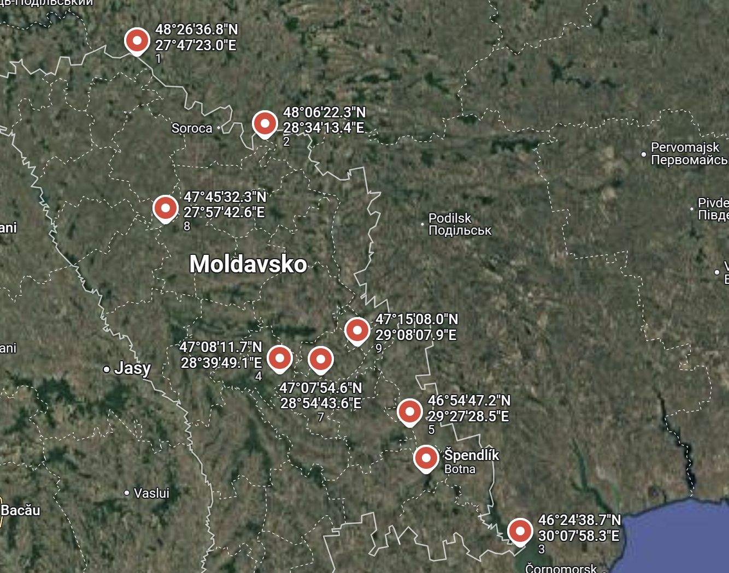
Fig.1 shows the location of nine sampling points according to their GPS coordinates.

All meta-data are presented in Annex 2. The labelling of the samples is in the following order: Sample 1 – Otaci, Sample 2 - Nimereuca, Sample 3 - Bălţi, downstream, Sample 4 - Ustia, Sample 5 - Goian, Sample 6 - Străşeni, Sample 7 - Gura Bîcului, Sample 8 - Mereneşti, and Sample 9 – Palanca.

3. Results and discussion

Metals in surface water

Introduction
Nine surface water samples were analysed for four selected metals: Cd, Pb, Hg and Ni.

Methods
ICP-MS was used for the determination of metals, utilizing on-line addition of internal standards. The used ICP-MS method is accredited according to EN ISO/IEC 17025: 2005.

Surface water samples

The four tested metals are among WFD priority substances. They were analysed in the dissolved fraction (after filtration in situ) of surface water samples.
Nickel (AA-EQS 4 μg/L), with a frequency of appearance (FoA) of 100%, was the most frequently detected metal, which is consistent with the results obtained in the second round of sampling. Nickel concentration in Samples 5 and 6 (4.99 µg/L and 5.35 µg/L, respectively) exceeded the AA-EQS value. The other sampling points are listed in order of descending concentration: Sample 8 (3.95 ug/L); Sample 3 (3.27 ug/L); Sample 4 (2.56 ug/L); Sample 7 (2.23 ug/L); Sample 1 (1.78 ug/L); Sample 9 (0.99 ug/L); and Sample 2 (0.96 ug/L).
Lead (AA-EQS 1.2 ug/L), with his FoA – 67% was present in the highest concentration in Sample 7 (0.33 ug/L), Sample 6 (0.27 ug/L); Sample 1 (0.20 ug/L); Sample 3 (0.14 ug/L); Sample 8 (0.12 ug/L); and in the remaining sample was at a concentration level between the LOQ and LOD of the given method.
In the third round of sampling Mercury (MAC-EQS 0.07 ug/L), and Cadmium (AA-EQS ≤ 0.08 ug/L) were not present in any of the samples examined.

Trend lines from three sampling campaigns
The metal determination results from October were fully consistent with those from the second sampling campaign. Nickel was the main metal with 100 percent FoE. Cadmium and mercury were not present.

Target screening of surface water samples by GC-MS-MS, GC-MS(NCI), LC-HR-MS and LC-MS/MS techniques

Introduction

Nine surface waters were subjected to targeted screening, covering all organic priority substances listed in the Directive 2013/39/EU, using gas chromatography and liquid chromatography coupled to mass spectrometry detectors. The obtained results were recorded in the Data Collection Template (DCT) developed by NORMAN Association for upload of data into NORMAN Database System – Chemical Occurrence Database (https://www.norman-network.com/nds/).

Methods

The following analytical methods were applied:

1. GC-MS/MS analyses were conducted by Agilent 7010 Triple Quadrupole (Agilent Technologies Deutschland, Waldbronn, Germany).
An DB-5mc column (30 m x 0.25 mm, 0.25 μm) from Agilent (Germany) coupled to the back-flush system was used at a constant flow of 1.6 ml/min. Hydrogen was used as mobile phase. The temperature gradient programme was initialized at 50°C, hold for 2 min, increased to 130°C with gradient 18°C/min, increased to 290°C with gradient 7°C/min, increased to 320°C (hold 5 min) with gradient 18°C/min. The sample introduction used stir-bar sorptive extraction (SBSE), where the stir bar covered with PDMS stationary phase was placed into the liner of the injector and subsequently the trapped substances were thermally released into the separation system. Data acquisition was performed in multiple reaction monitoring (MRM) mode. This system was also equipped with the static headspace option for analyzing VOC compounds.

2. GC-MS(NCI) analyses were conducted by a Agilent 5975C Triple axis Quadrupole (Agilent Technologies Deutschland, Waldbronn, Germany) working in the Negative Chemical Ionization (NCI) mode with methane.
An DB-5mc column (15m x 0.25 mm, 0.25 μm) from Agilent (Germany) coupled to the back-flush system was used at a constant flow of 2.0 ml/min. Hydrogen was used as mobile phase. The temperature gradient programme was initialized at 50°C, hold for 2 min, increased to 320°C (hold 5 min) with gradient 20°C/min. The sample introduction used PTV injector allowing to inject up to 50 ul of sample extract. Data acquisition was performed in selected ion monitoring (SIM) mode. This system was used for compounds having electronegative atoms.

3. LC-ESI-QTOF-MS analyses were conducted using an ultra high-performance liquid chromatographic (UHPLC) system with a HPG-3400 pump (Dionex Ultimate 3000 RSLC, Thermo Fischer Scientific, Dreieich, Germany) coupled to a QTOF mass spectrometer (Maxis Impact, Bruker Daltonics, Bremen, Germany).
Chromatographic separation was performed using an Acclaim RSLC C18 column (2.1 x 100 mm, 2.2 μm) from Thermo Fischer Scientific (Dreieich, Germany) preceded by a guard column of the same packaging material, thermostated at 30°C. For positive ionization mode (PI), the mobile phases were water/methanol 90/10 (solvent A) and methanol (solvent B) both containing 5 mM ammonium formate and 0.01% formic acid. For negative ionization mode (NI), the mobile phases consisted of water/methanol (solvent A) and methanol (solvent B) both acidified with 5 mM ammonium acetate. The adopted gradient elution programme was the same for both ionization modes, starting with 1% B with a flow rate of 0.2 mL min-1 for 1 min and it increased to 39% in 2 min (flow rate 0.2 mL min-1), and then to 99.9 % (flow rate 0.4 mL min-1) in the following 11 min. Then, it was kept constant for 2 min (flow rate 0.48 mL min-1), then the initial conditions were restored within 0.1 min, kept for 3 min and then the flow rate decreased to 0.2 mL min-1. The injection volume was 5 μL.
The quadrupole time-of-flight mass spectrometry (QTOF-MS) system was equipped with an electrospray ionization interface (ESI), operating in positive and negative mode, with the following operation parameters: capillary voltage 2500 V (PI) and 3500 V (NI); end plate offset, 500 V; nebulizer pressure 2 bar; drying gas 8 L min−1 and gas temperature 200°C. The QTOF-MS system was operated in data-independent (broadband collision-induced dissociation (bbCID)) acquisition, as well as in data dependent (Auto MS/MS) acquisition mode and recorded spectra over the range m/z 50−1200, with a scan rate of 2 Hz. A QTOF-MS external calibration was performed daily with the manufacturer's solution. The instrument provided a typical resolving power (FWHM) between 36,000-40,000 at m/z 226.1593, 430.9137 and 702.8636.

4. LC-ESI-MS/MS analyses were conducted by a Thermo UHPLC Accela system interfaced with a Thermo TSQ Quantum Access Triple Quadrupole Instrument (Thermo, San Jose, CA, USA).
An X-Bridge C18 column (2.1 x 50 mm, 2.5 μm) from WATERS (Dublin, Ireland) preceded by a guard column was used at a constant flow of 100 μL min⁻¹, thermostated at 30°C. The mobile phases consisted of water containing 0.1 % formic acid (v/v) (solvent A) and methanol (solvent B). The gradient programme was initialized with 50% B, increased to 100% B in 9 min and then it kept constant for 3 min. Afterwards, the initial conditions were restored within 1.5 min and kept constant for 3.5 min. The injection volume was set up to 5 µL. The ESI probe was operated in Positive Ionization. ESI voltage was set at 4000 V. The sheath gas (N2) flow rate was set at 40 A.U (Arbitrary Units), the auxiliary gas (N2) flow rate was set at 20 A.U and the ion transfer capillary temperature was set at 270⁰ C. Data acquisition was performed in multiple reaction monitoring (MRM) mode.

Results of target screening – pesticides
GC-amenable compounds

The results of the third round of analyses revealed the same range of compounds as the previous two rounds. The change that was observed was that Hexachlorocyclohexane (AA-EQS (20 ng/L) - the insecticidal properties of the HCH led to its extensive use on fruit, vegetables, and forest crops. It was the most frequently detected GC pesticide, with its FoA standing at 89%. Its highest concentration was recorded in Sample 8 (2.02 ng/L).
synthetic organophosphorus insecticide and acaricide, Chlorpyrifos (FoA 33%) was found at the highest concentration in Sample 3 (25.2 ng/L), Sample 7 (9.88 ng/L), and Sample 5 (1.45 ng/L). Chlorfenvinphos (AA-EQS - 100 ng/L) was detected in two samples, namely Sample 3 (1.22 ng/L), and Sample 8 (1.05 ng/L).
DDT total was determined in Sample 8 at 0.81 ng/L (p,p’-DDD 0.52 ng/L and p,p’-DDE 0.29 ng/L) and Sample 7 at 0.79 ng/L (p,p’-DDD 0.46 ng/L and p,p’-DDE 0.33 ng/L).
All other GC-amenable pesticides were below the limit of detection (LOD) of the respective method (cf. also results in the attached DCT).
LC-amenable compounds
The results once again confirmed the presence of urea and triazine pesticides in water samples. Of the pesticides detected in the LC group, Diuron (AA-EQS – 200 ng/L) had the highest FoA at 78%, with the highest concentration recorded in Sample 7 (72 ng/L). The next highest concentrations were found in samples – Sample 6 (41 ng/L), Sample 3 (30 ng/L), Sample 5 (29 ng/L), Sample 8 (4.4 ng/L), and Sample 9 (2.1 ng/L). Another pesticides detected at some frequency were Terbutryn (FoA 67%; AA-EQS 65 ng/L) with its highest concentration in Sample 1,2 (15 ng/L),Isoproturon (AA-EQS 300 ng/L) with its highest concentration in Sample 7 (2.9 ng/L).

Results of target screening – VOCs
The method used for the determination of VOCs included Aniline, Styrene, and Toluene in addition to the substances listed in the Directive 2013/39/EU.
The priority substances Chloroform was determined in Sample 3 (0.42 ug/L), Sample 7 (0.21 ug/L), and Sample 4 (0.13 ug/L).

Results of target screening – HCBDD, BDEs, and C10-13 Chloroalkanes (SCCPs)
The method used for the determination of these groups of compounds utilised NCI, which resulted in greatly improved sensitivity and selectivity.
Of these substances, only SCCPs (AA-EQS 400 ng/L) were detected in Sample 3 (49.4 ng/L). Sample 8 tested positive for the presence of SCCPs, however at a concentration level between the LOQ and LOD of the given method. SIM mode of this method was using for identification of brominated compounds special isotope occurrence pattern of bromine atoms – m/z 79 and 81. This pattern was detected also in mass spectra of several non-targeted compounds in Samples 3, which indicates presence of other brominated substances. Unfortunately, these substances could not be identified as they were not on the list of targeted compounds in this study, however, potential environmental health hazards of compounds containing bromine could trigger their future identification/monitoring.

Results of target screening – Perfluorinated compounds (PFCs)
An update (still not in force) of the Directive 2013/39/EU defines 24 PFCs that belong to the Perfluorooctane sulfonic acid and its derivatives (PFOS) group. The method used (LC-ESI-QTOF-MS) covers extended list of 40 PFCs, including those in the updated directive.
The results showed that the AA-EQS (0.65 ng/L) for Perfluorooctane sulfonic acid and its derivatives (PFOS) listed in the Directive 2013/39/EU, were not exceeded in any samples.
Complete results of the PFCs are given in the attached DCT in the sheet – Analytical results. Individual concentrations of the determined compounds were compared with their respective Lowest PNEC values in the NORMAN Ecotoxicology database (https://www.norman-network.com/nds/ecotox/lowestPnecsIndex.php).
None of the concentrations exceeded these threshold values.

Results of target screening – Polycyclic Aromatic Hydrocarbons
The applied GC-MS/MS method uses isotopically labelled standards for better quantification. PAHs with the highest FoA were Anthracene and Fluoranthene (FoA 56%, respectively 33%). The highest concentrations of these two PAHs were found in Sample 7 (3.11 ng/L and 0.42 ng/L, respectively). None of the regulatory AA-EQS value was exceeded in any of the samples.

Results of target screening – Industrial pollutants
This group includes priority substances Di(2-ethylhexyl)phthalate (DEHP), Nonylphenols and Octylphenols. DEHP and Nonylphenols were determined above the limit of quantification (LOQ) of the method with their FoA 56%, respectively 33%, however, the concentrations did not exceed their respective AA-EQSs. The highest concentrations of these two compounds were determined in Sample 3 - DEHP (0.68 ug/L), and Nonylphenols (0.21 ug/L).

Results of target screening – Tributyltin compounds/Tributyl cation
This method employs derivatization with NaBEt4 as a derivatizing agent and addition of isotopically labeled standards in order to maximize the reliability of determination as well as quantification. Tributyltin compounds were determined in three samples. Detected TBTs were over their AA-EQS (0.2 ng/L) in the following descending order: Sample 1 (7.86 ng/L), Sample 2 (6.81 ng/L), and Sample 9 (1.01 ng/L).

4. Conclusions
Results of the third revealed the presence of compounds that had already been found in the previous two campaigns. sampling campaign have a similar profile of detected compounds to those from the previous campaigns and indicate that several WFD priority substances from the Directive 2013/39/EU have been determined in the nine collected samples. The difference from previous campaigns was that only Tributyltin compounds, such as WFD PS, were found in three samples above their EQS. This fact was confirmed by the water levels at the sampling points, where it can be said that most of them had the highest levels of all three samplings.

Sampling sites with the highest number of detected WFD priority substances were Sample 7 (24 compounds), Sample 8 (17 compounds), and Sample 3 (14 compounds).
In-situ measurements of conductivity, total hardness, oxygen content, visual and sensory observation of individual samples (unpleasant smell, oil stains and high turbidity) indicated pollution of majority of the sampling sites from nearby pollution sources at the time of sampling.
All results have been recorded in the standardized DCT and are ready for upload into the NORMAN Database System – Chemical Occurrence Database for further processing/prioritisation.

Annex 1
Sampling protocols – sampling campaign October 2025

The individual sampling sites are presented in order of the planned individual sampling dates according to the sampling plan (Fig.2).
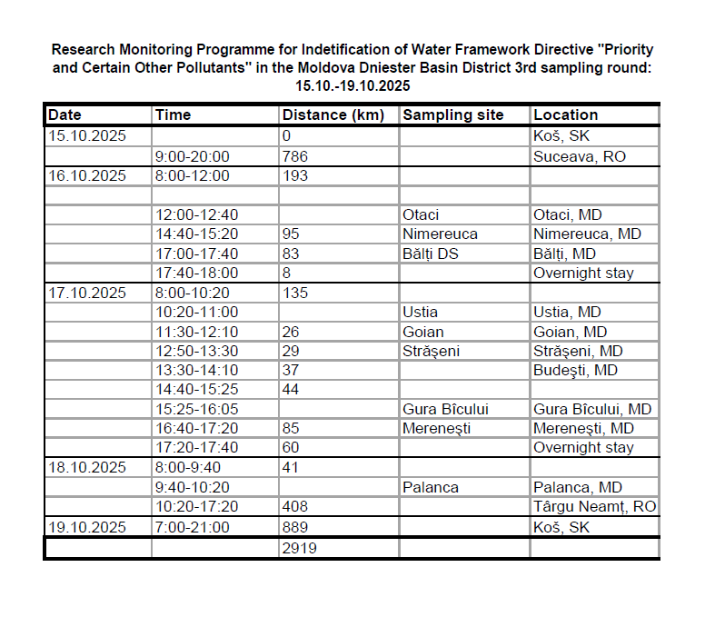

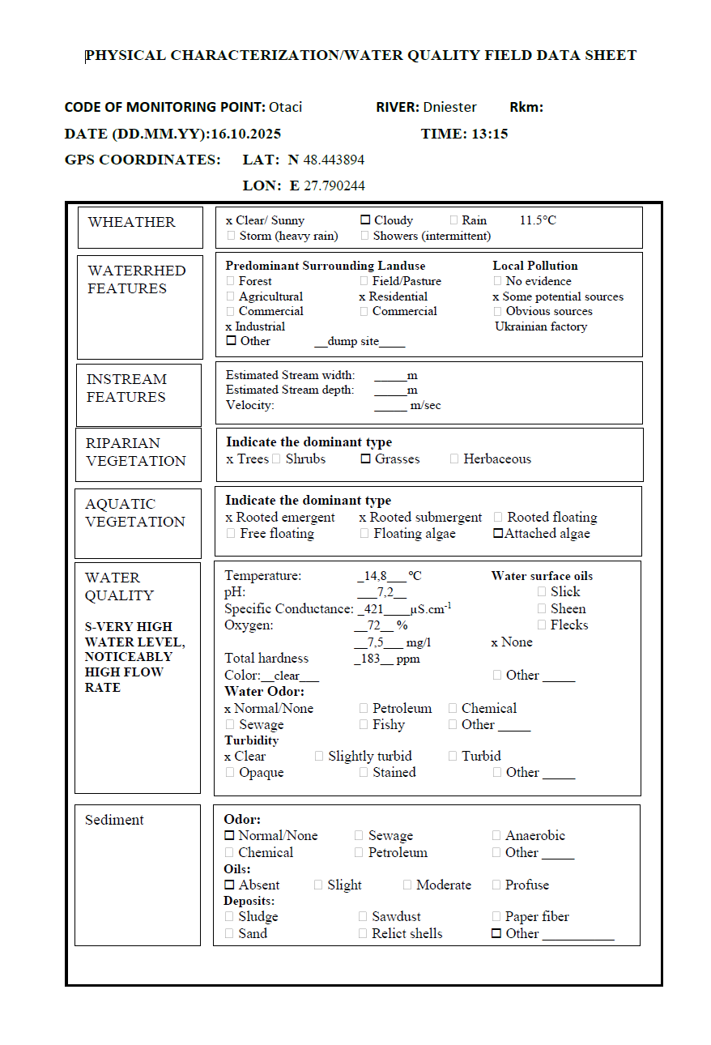
Sampling site - Otaci – in pictures

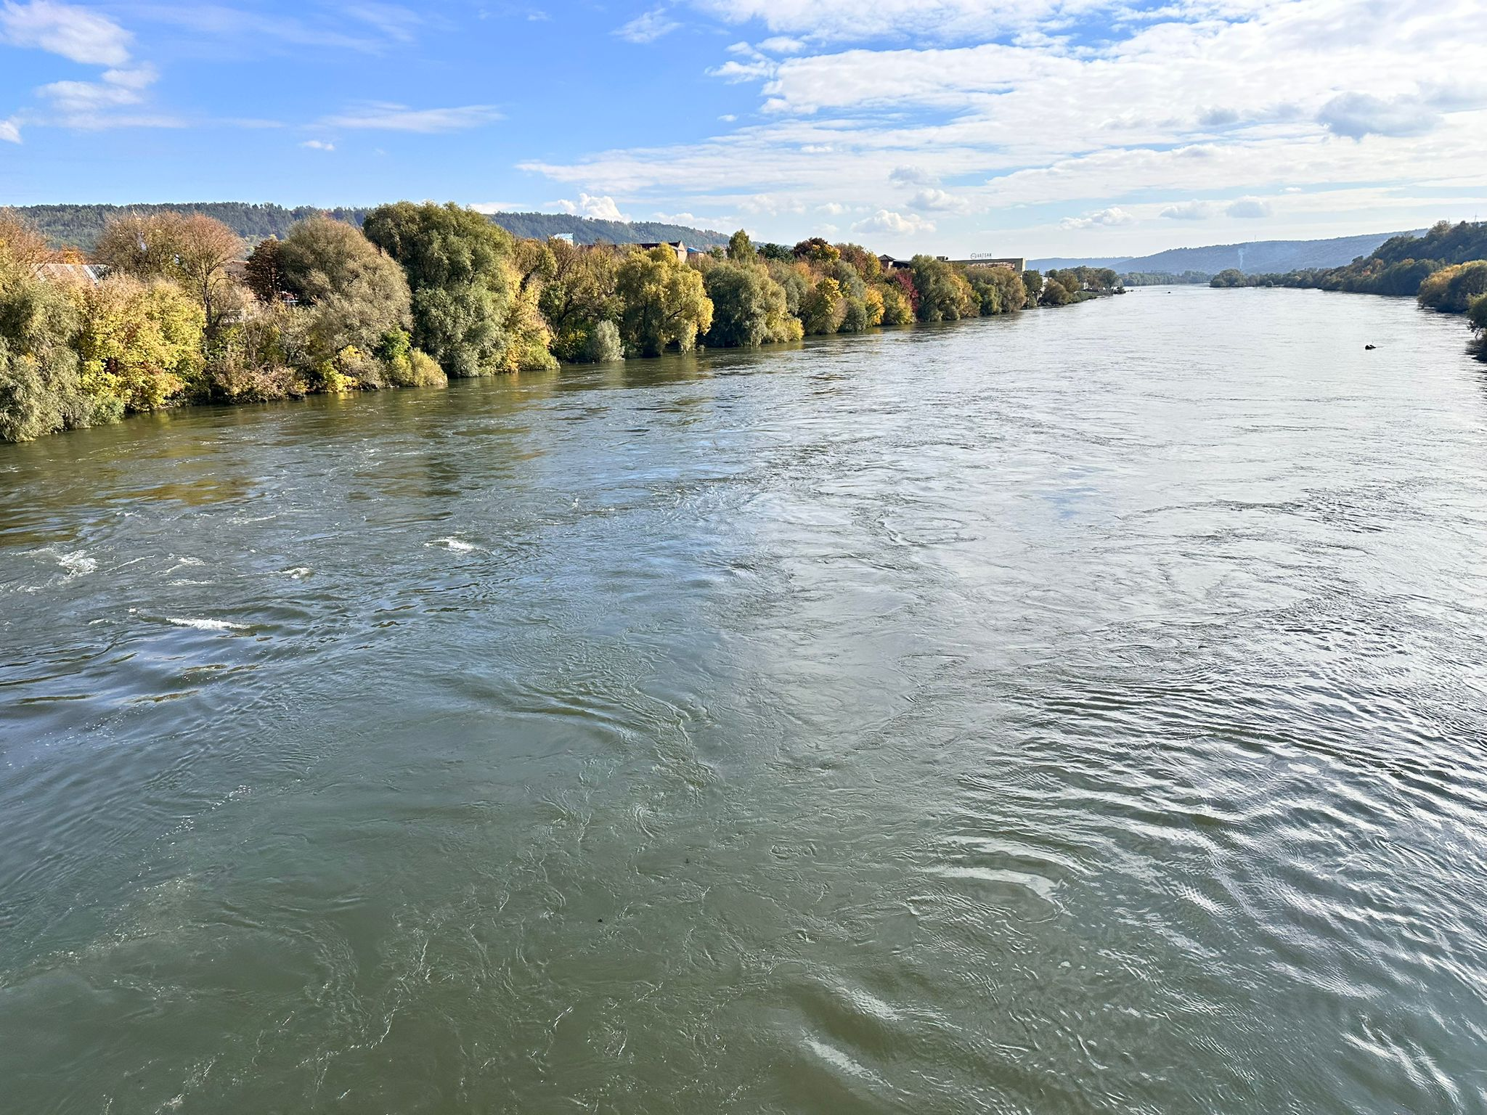



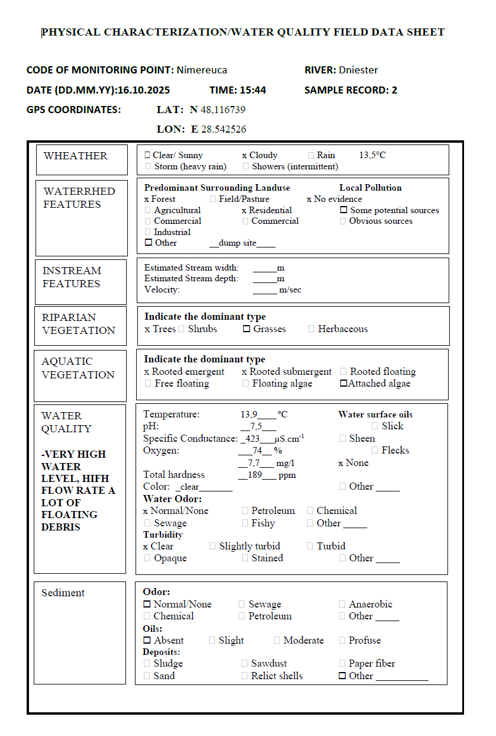
Sampling site - Nimereuca – in pictures

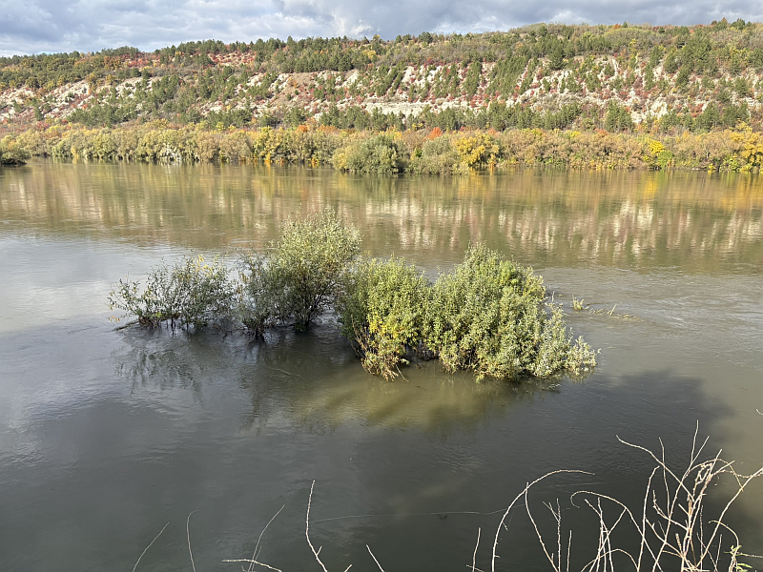


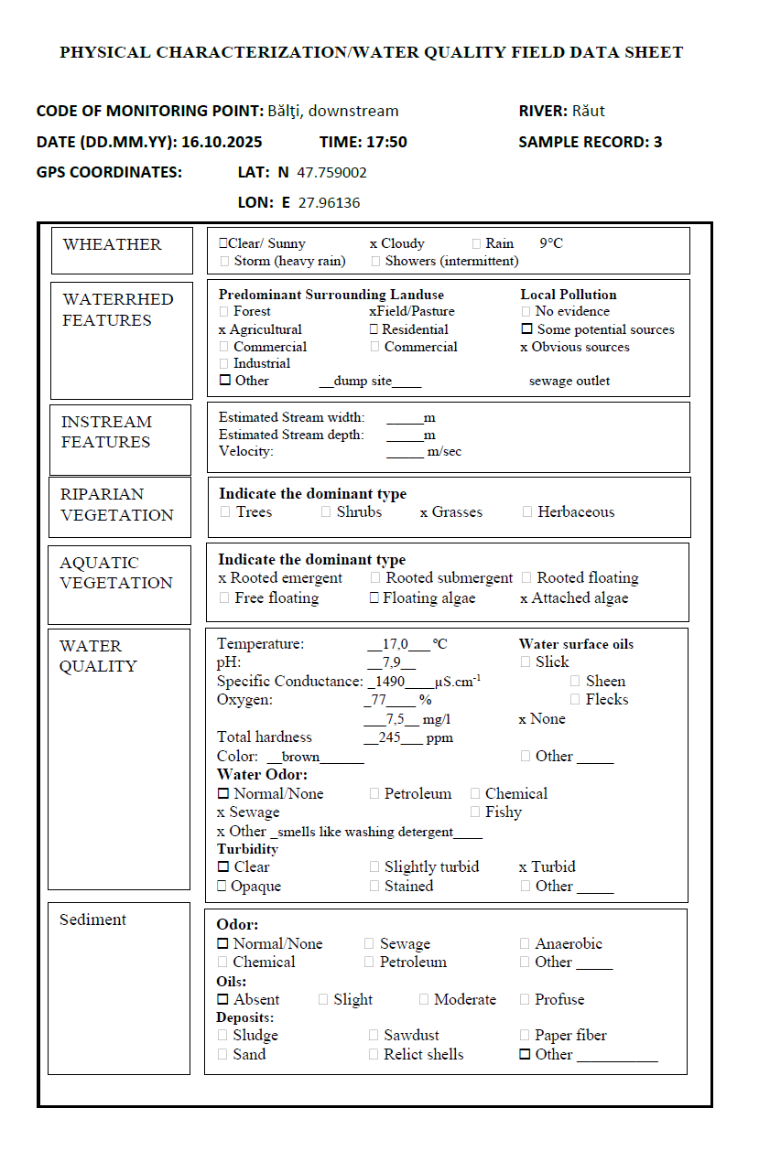
Sampling site – Balti downstream – in pictures
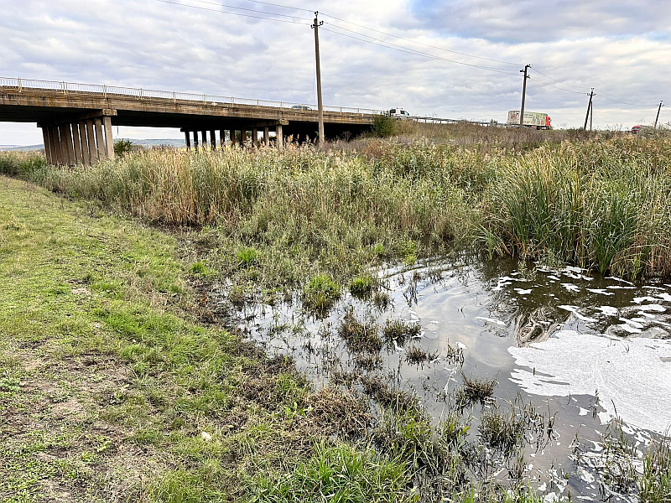
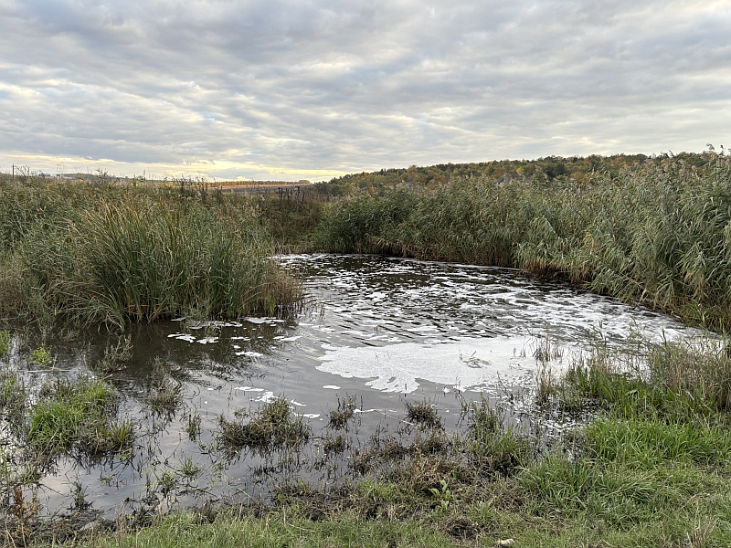

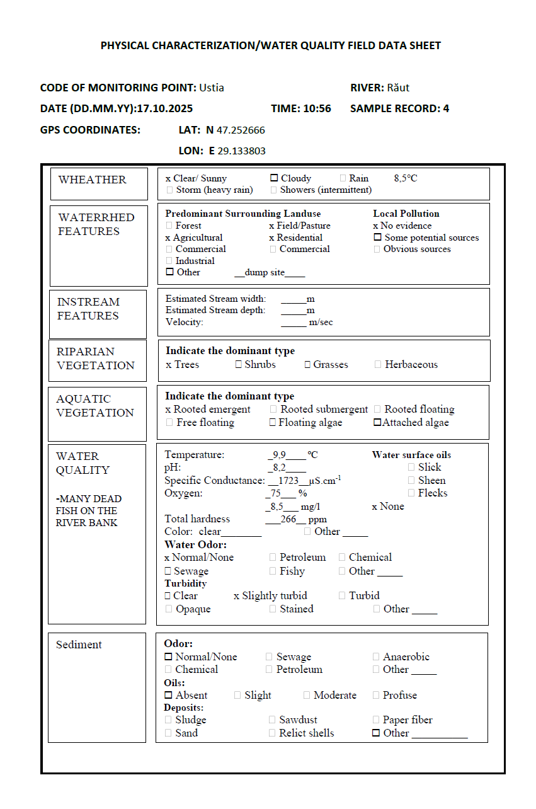
Sampling site – Ustia – in pictures
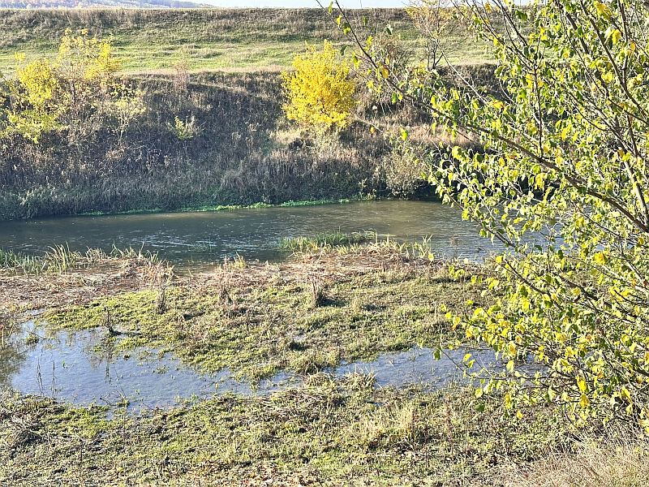
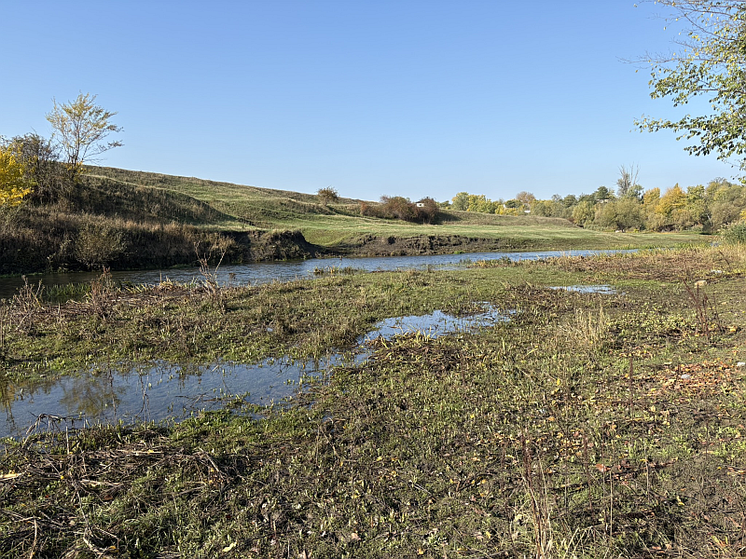
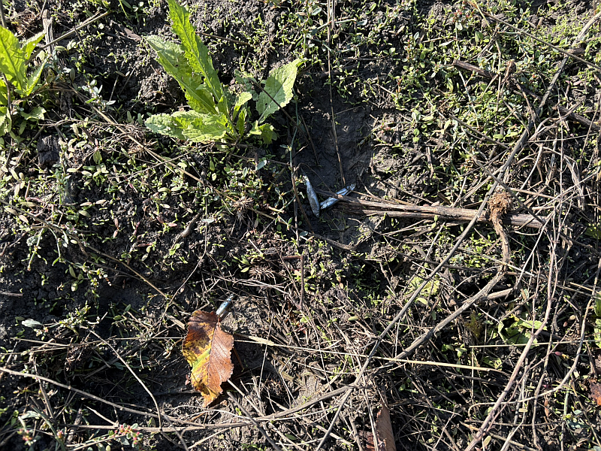
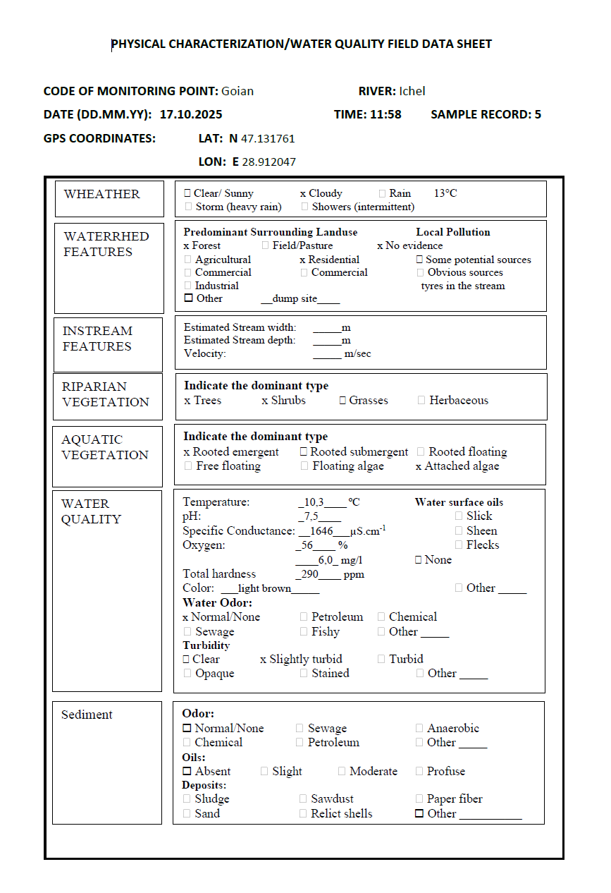
Sampling site – Goian – in pictures
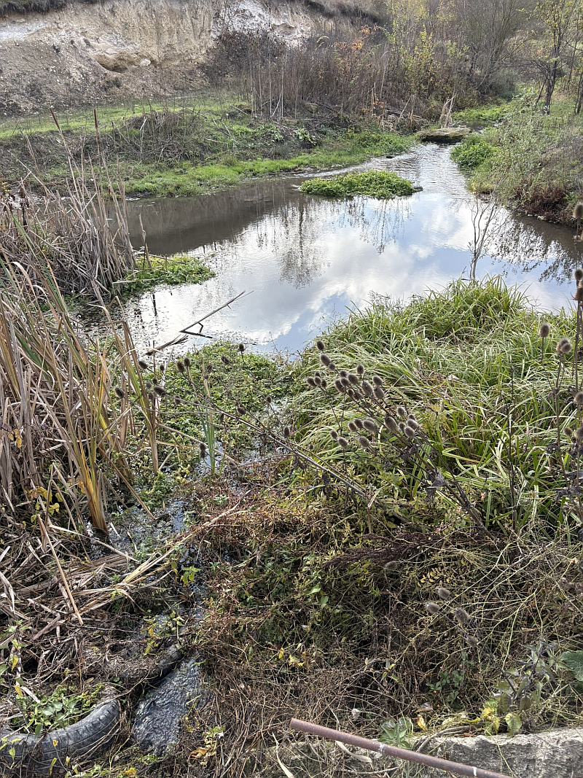
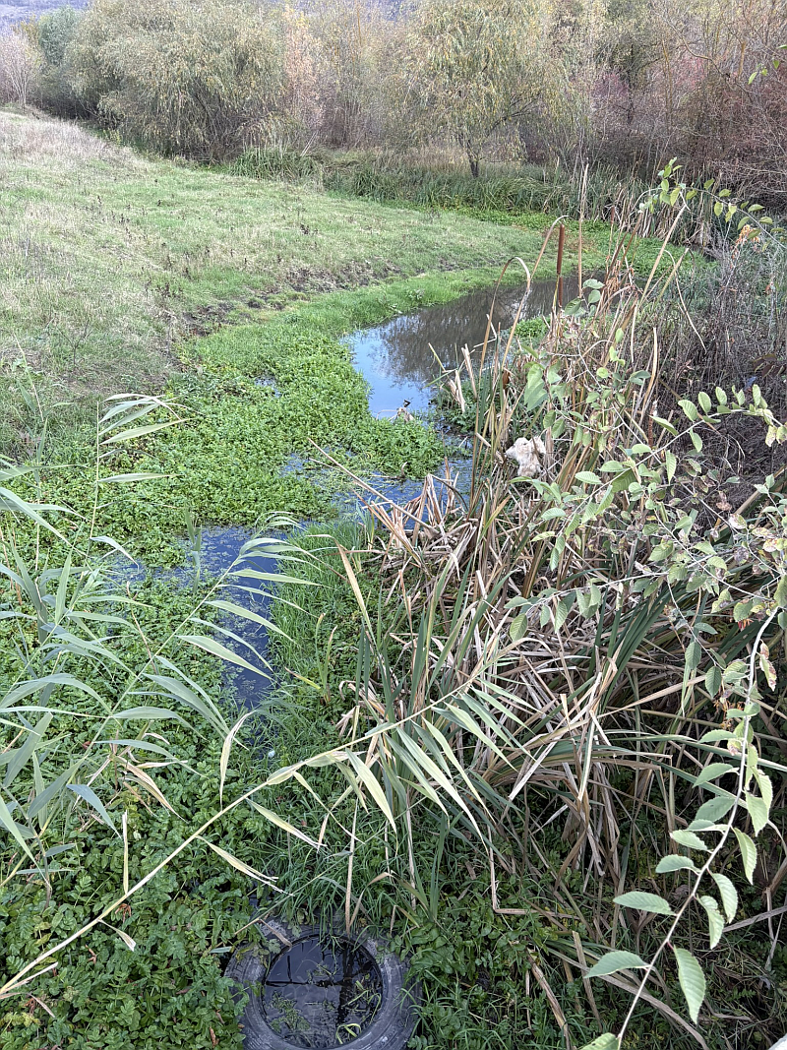

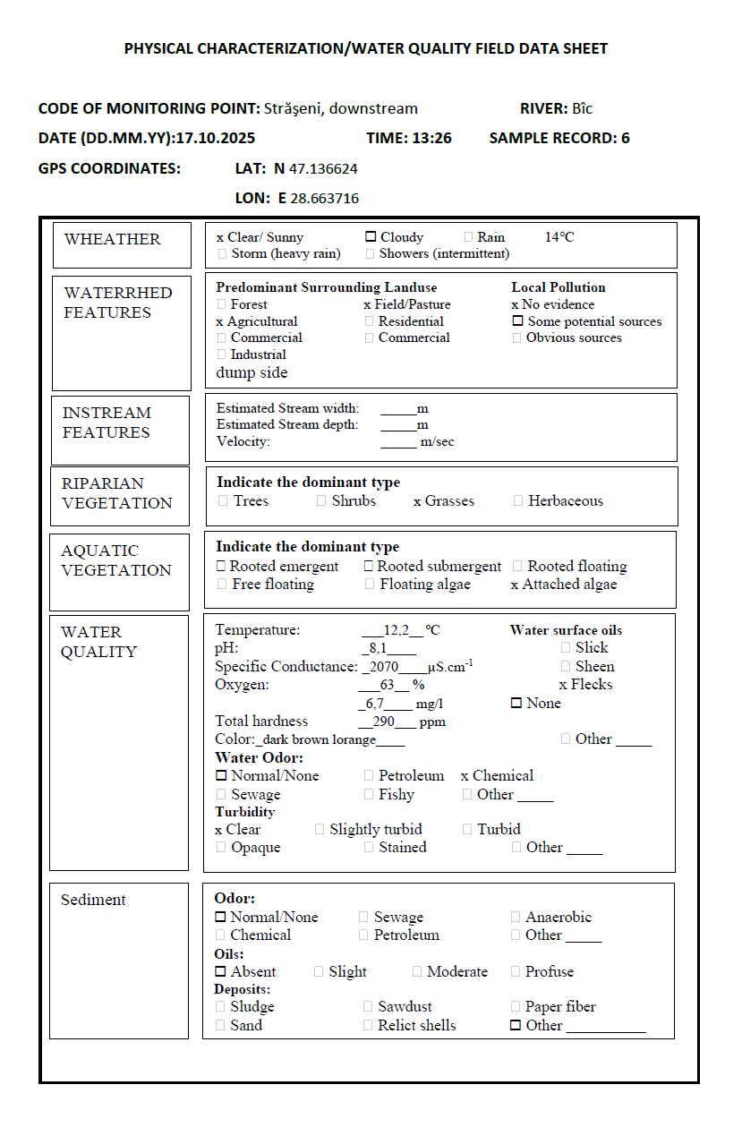
Sampling site – Straseni – in pictures
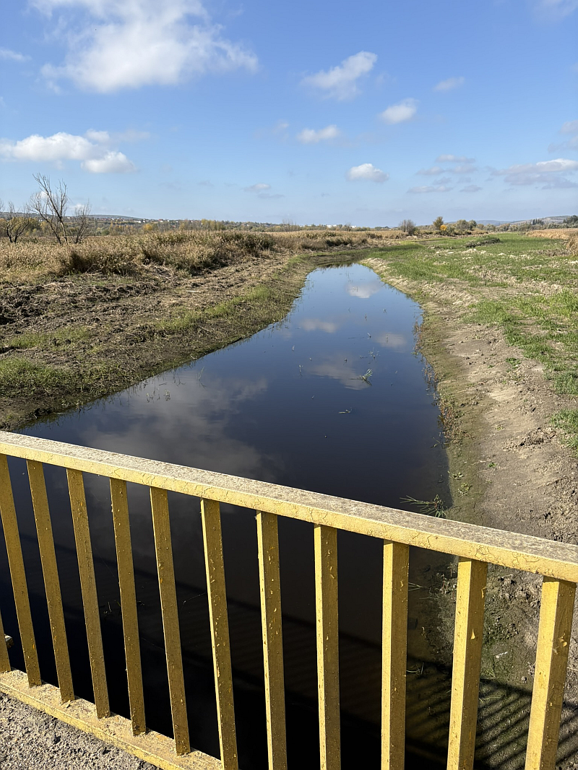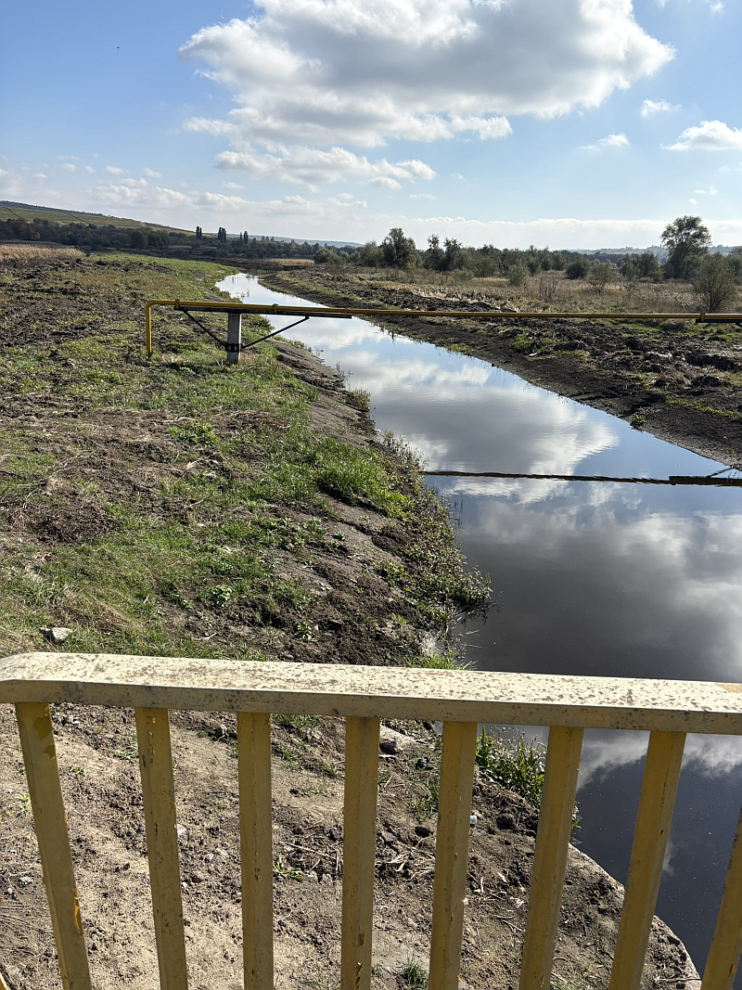
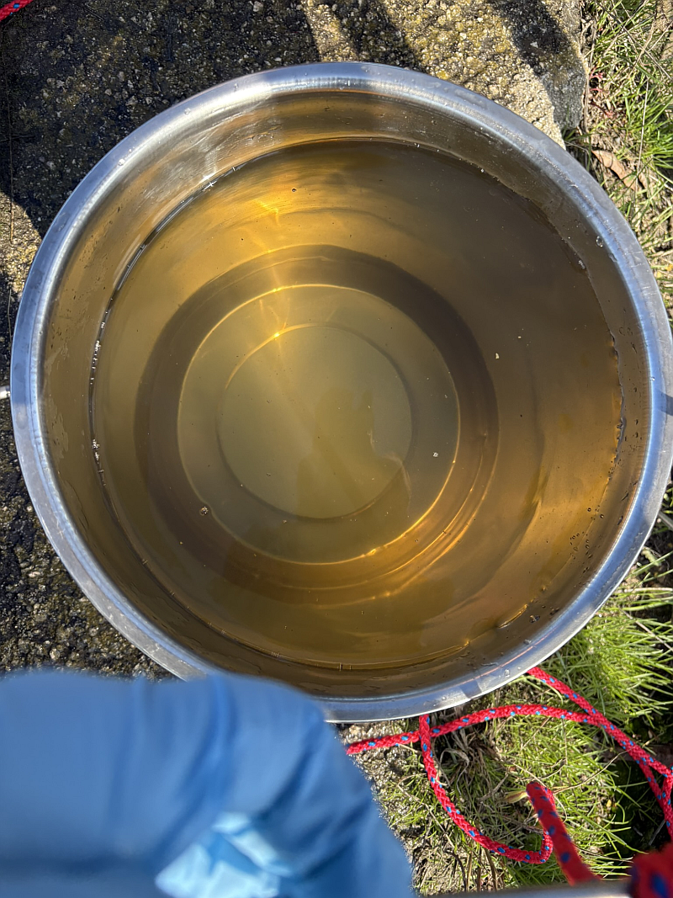
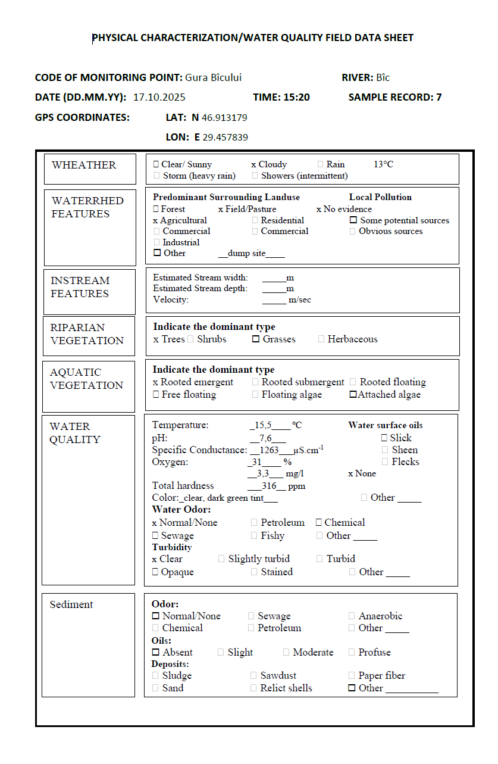

Sampling site – Gura Bicului – in pictures
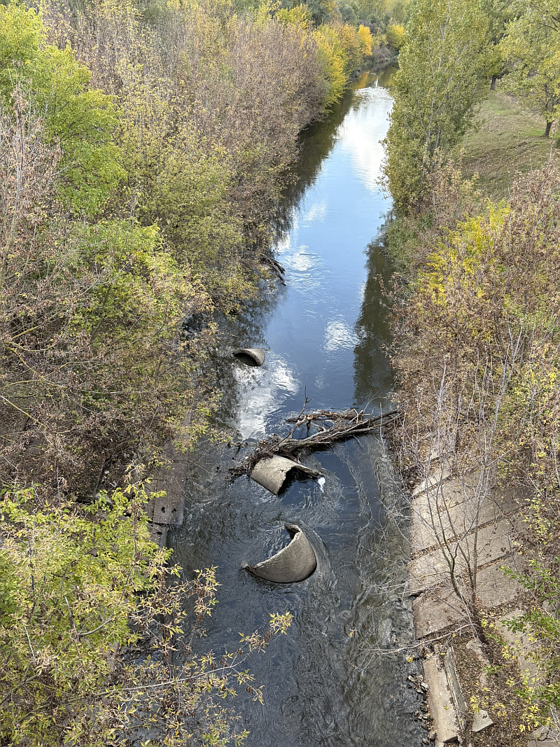
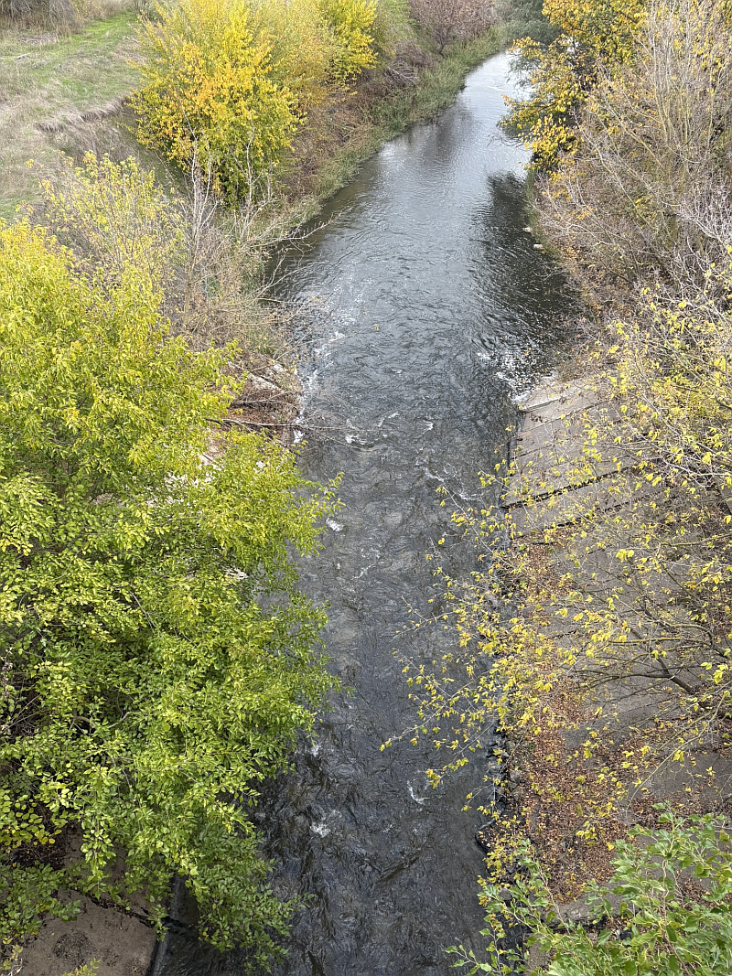

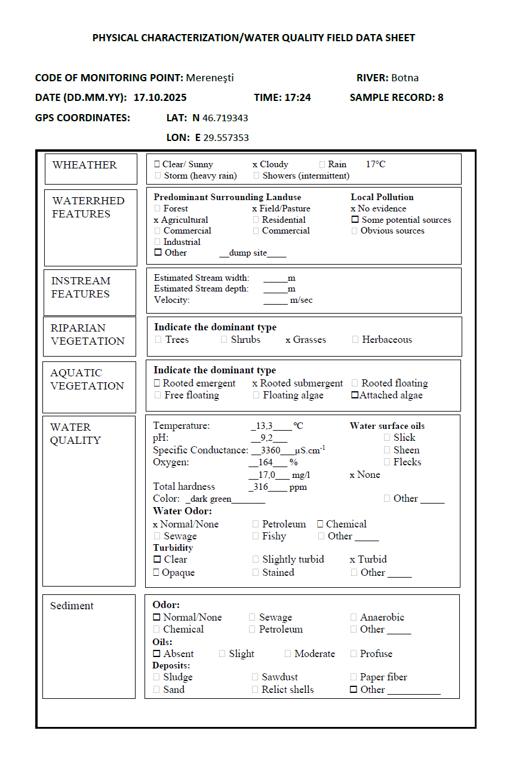

Sampling site – Merenesti – in pictures

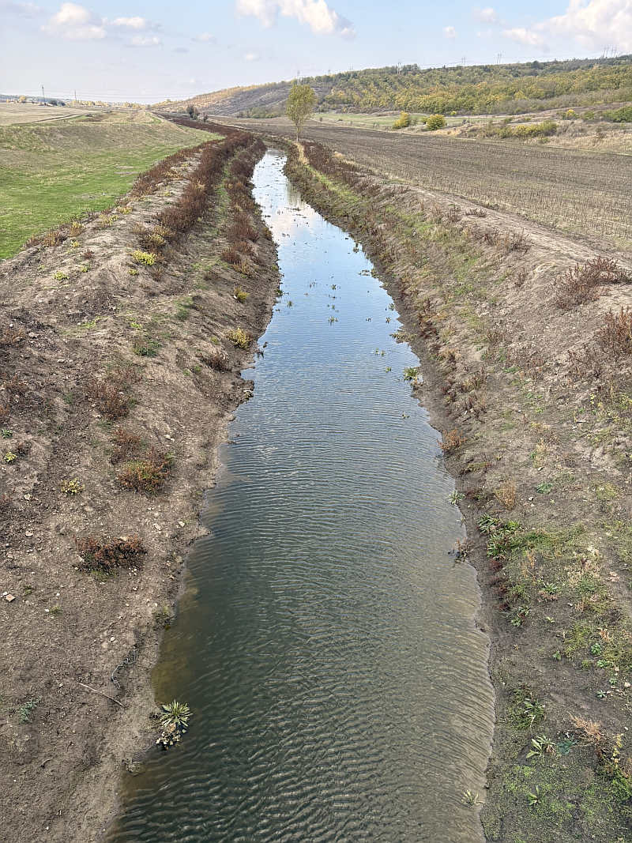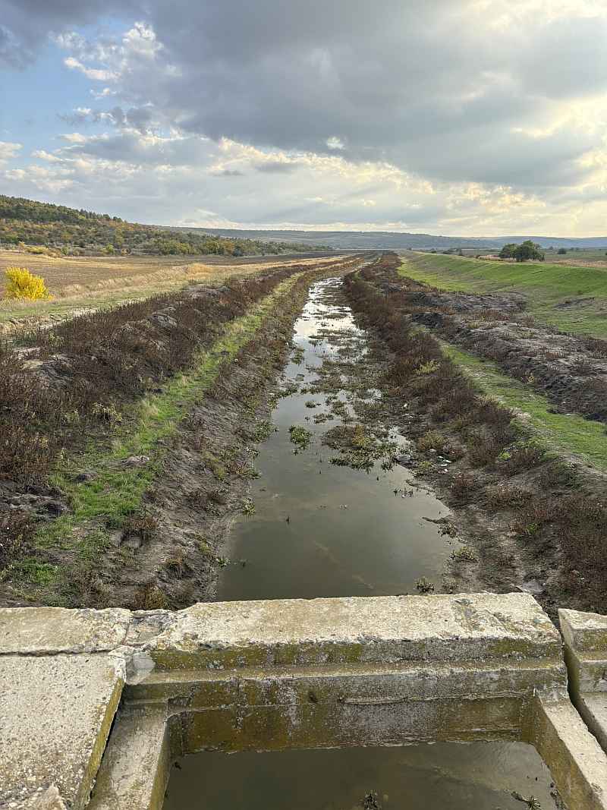

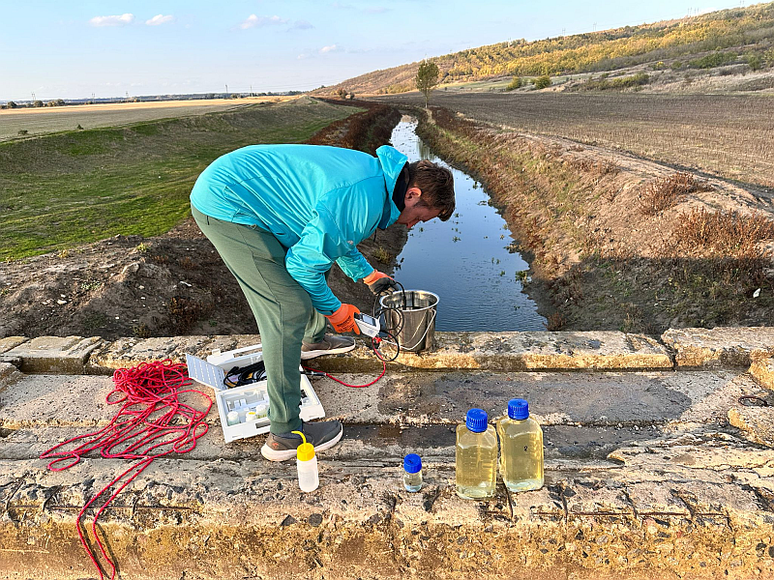
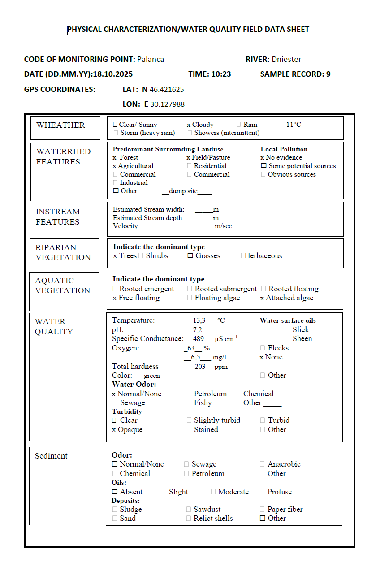
Sampling site – Palanca – in pictures


